Lab 10: Balance Control

EEE4514

April 11, 2017

**Gabriel Stroe**

# Filtering

## Overview

The purpose of this lab is to configure the rotary pendulum system so it will begin to balance itself after the user moves it to 10 degrees.

## Theory and Methods

To accomplish this, we need to take the Lab 9 system and turn it in to a subsystem for this new system to read from. From there we add a PD controller to the to the system with the following K values:  
Kp_theta = -2  
Kp_alpha = 30  
Kd_theta = -2  
Kd_alpha = 2.5

Where the alpha is the pendulum and the theta is the rotator arm. This is also based on the following formula given to us by the lab manual:  


In addition, we need to add a control switch that only enables the function when the pendulum is at a +/- 10 degrees of the top, otherwise the pendulum wouldn’t be able to balance itself.

Lastly we need to make sure that the finale values to the write analog device is all positive otherwise the system will make itself less stabile instead of more.

## Results

Once we built the system to match the provided specifications, it worked correctly. The only issue that I encountered was with the control switch needed to be in zero-based contingency vs one-based contingency. Once that was change that lab work smoothly.

The following chart is the system when we first got it to balance itself. Here the system is already standing and a small tap was given to show that it will still balance itself:

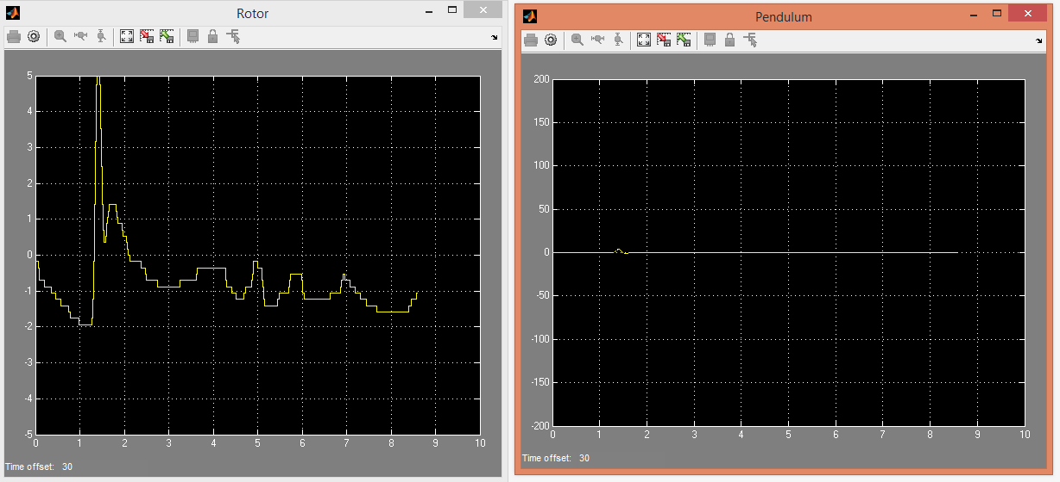

Then after that we were asked to try moving the constant that holds the rotor arm in certain positions. So, the following are two outputs, the first at 30 degrees and the second at 60 degrees:

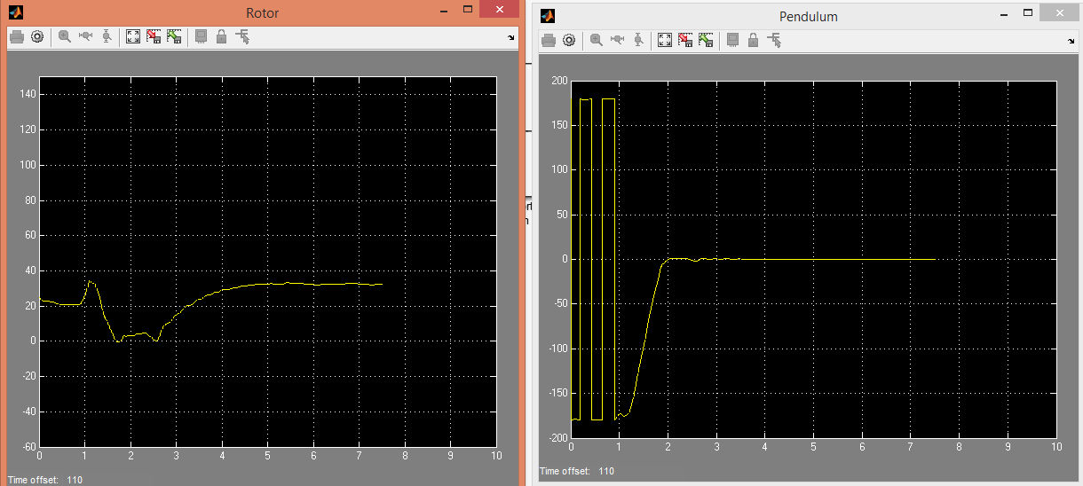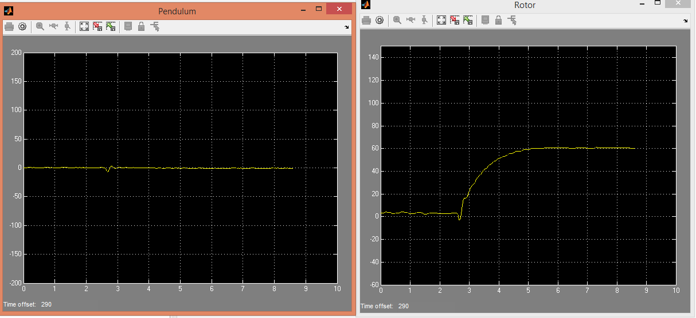

The first chart I moved into position and the second was actually change while the system was running.

## Questions

1. The arm moves back and forth rapidly trying to balance the pendulum
2. The input to the location of the rotary arm.

## Conclusion

This lab took some time to build but once we had it created and worked out a few settings that were incorrect. The system can balance itself immediately when rotated up to 10 degrees from 0 and the next step will be to have it reach that 10-degree threshold by itself.